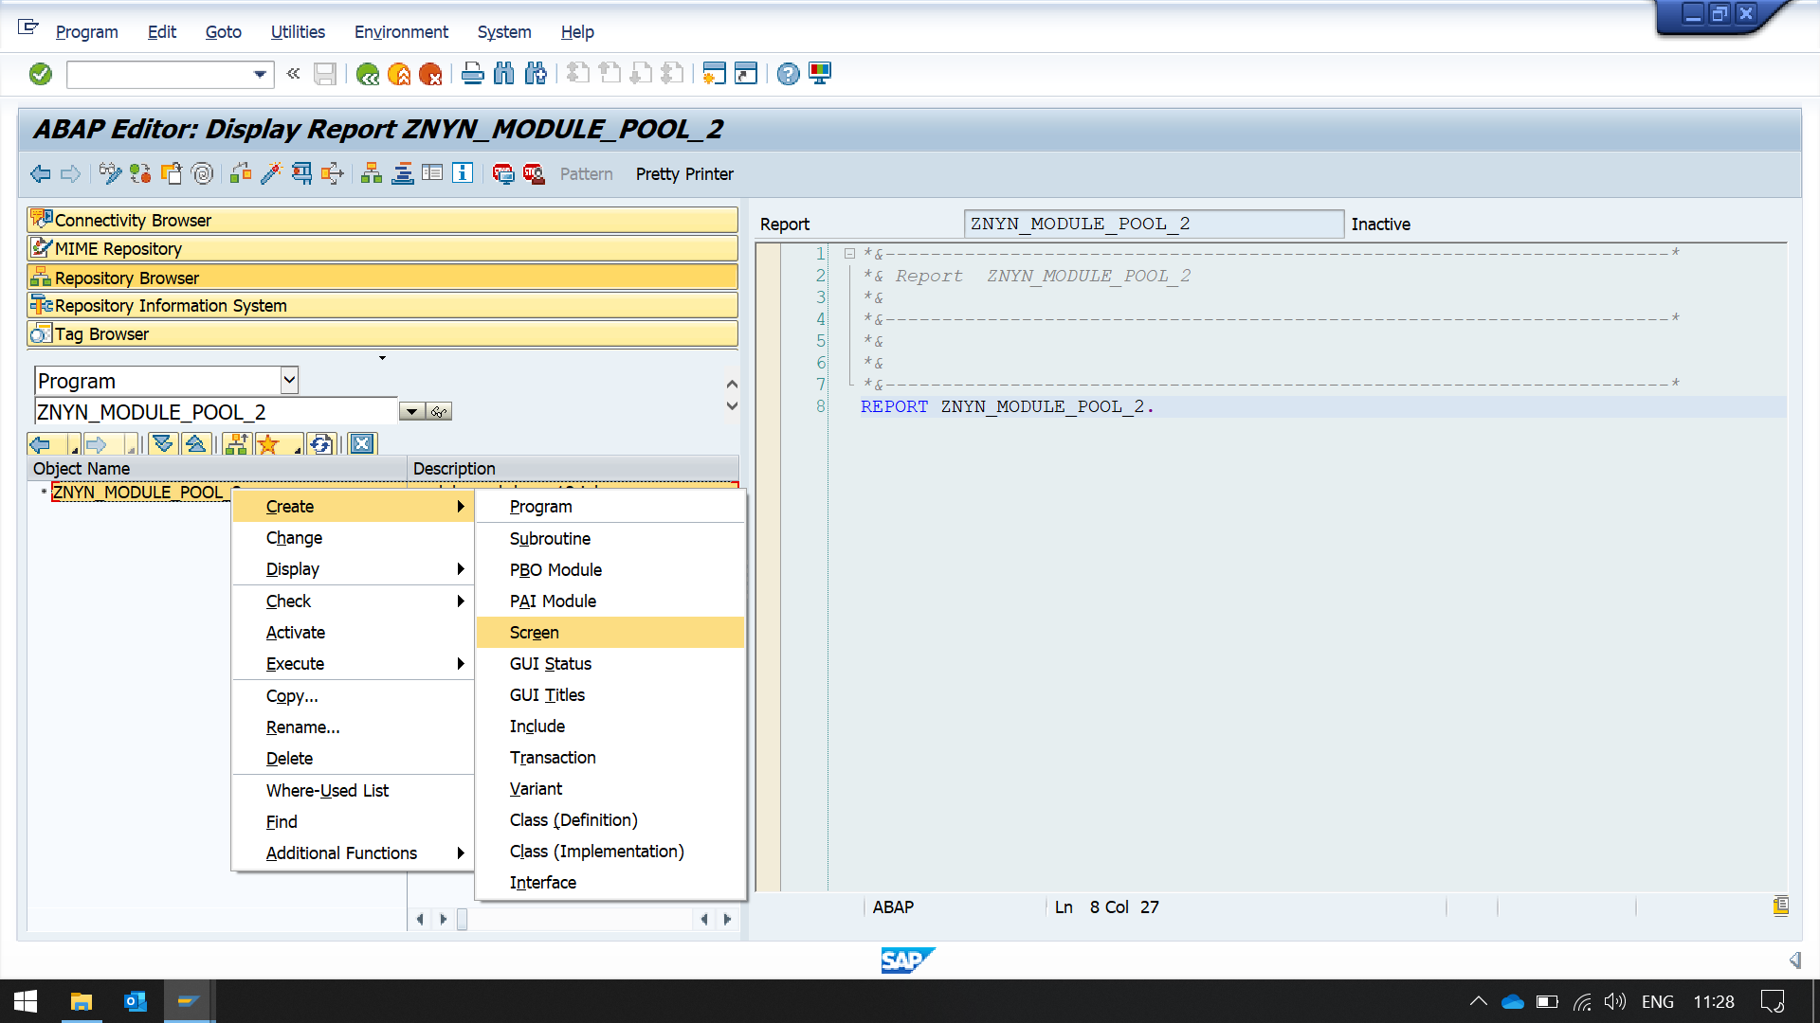

Entered screen other than 1000, CLICK ON LAYOUT BUTTON

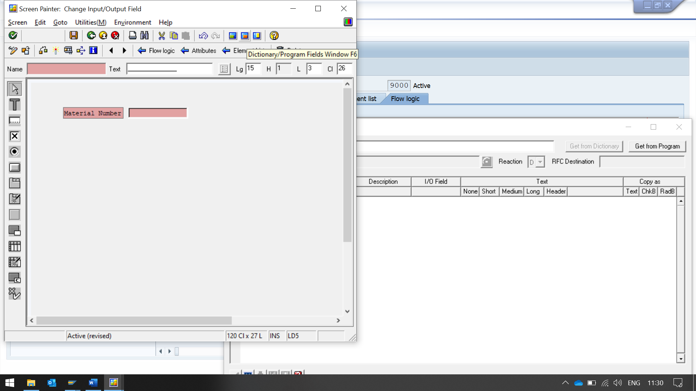

Click on display dictionary program fields, Then enter table name as MARA

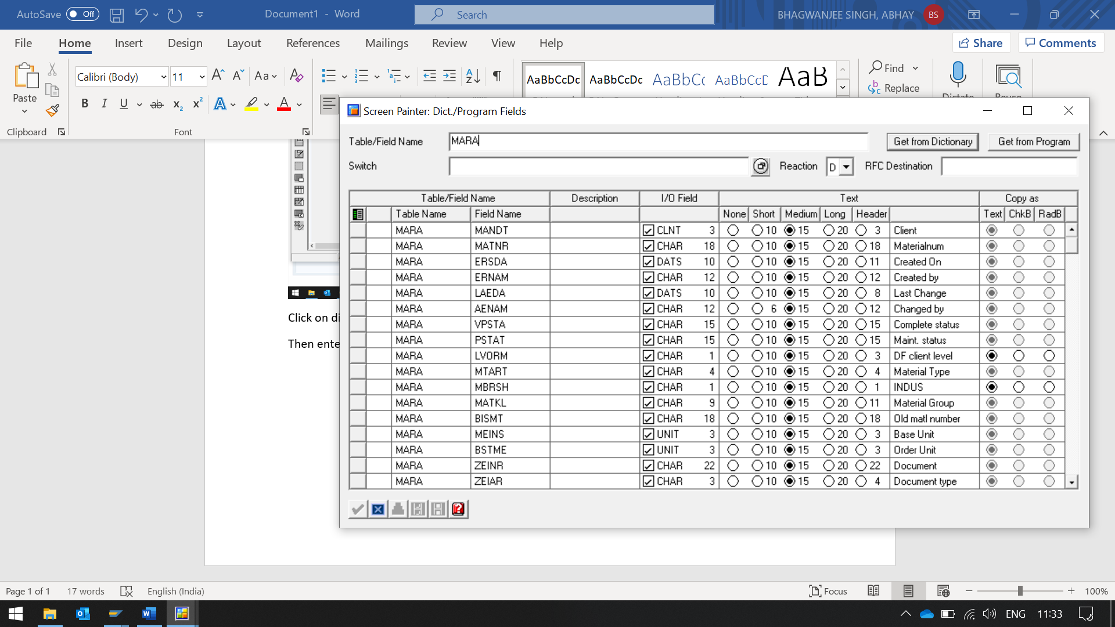

Select the desired field. Here we select matnr

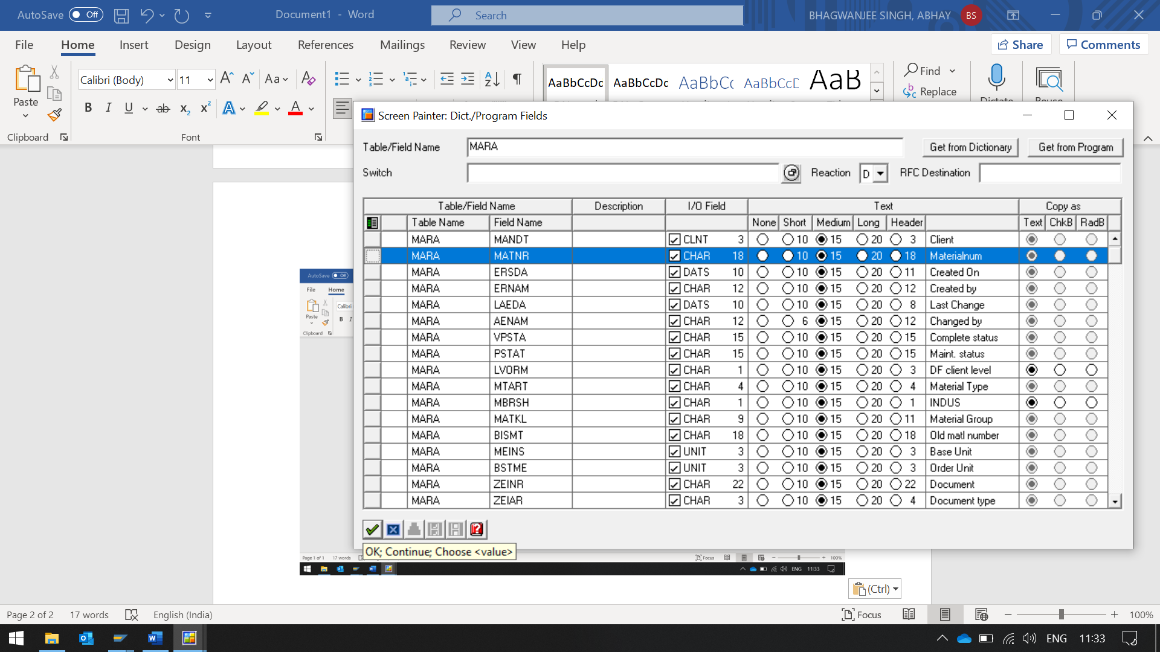

SELECT ONE DESIRED FIELD, then place it.

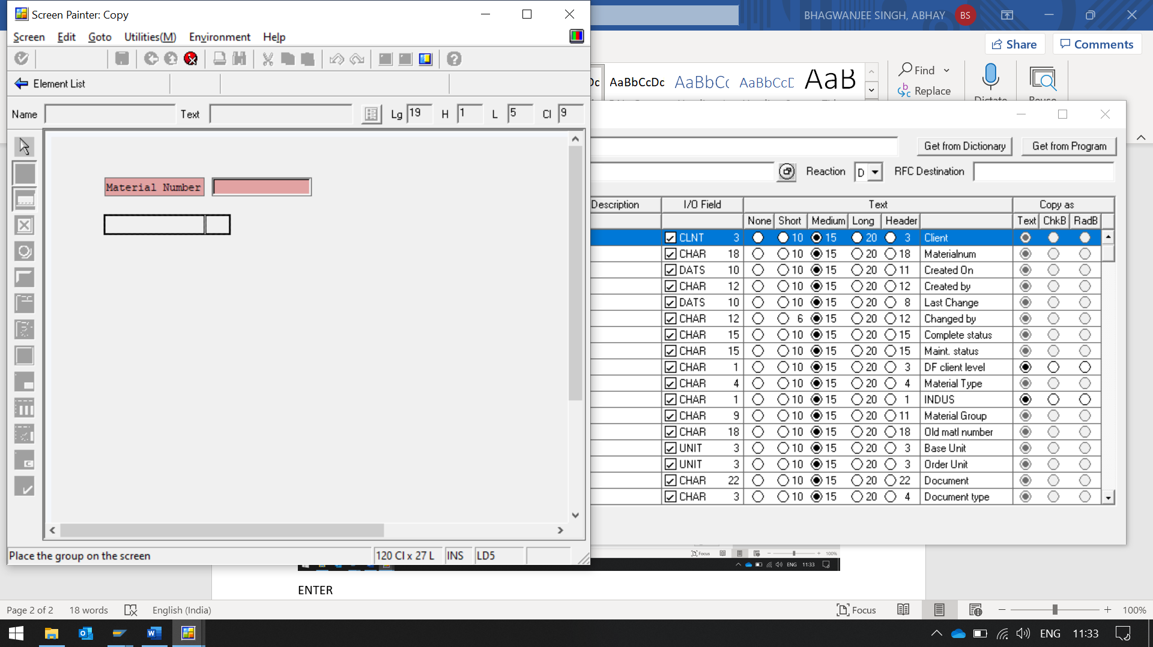

IT WILL PROVIDE A INPUT FIELD WiTH LABEL

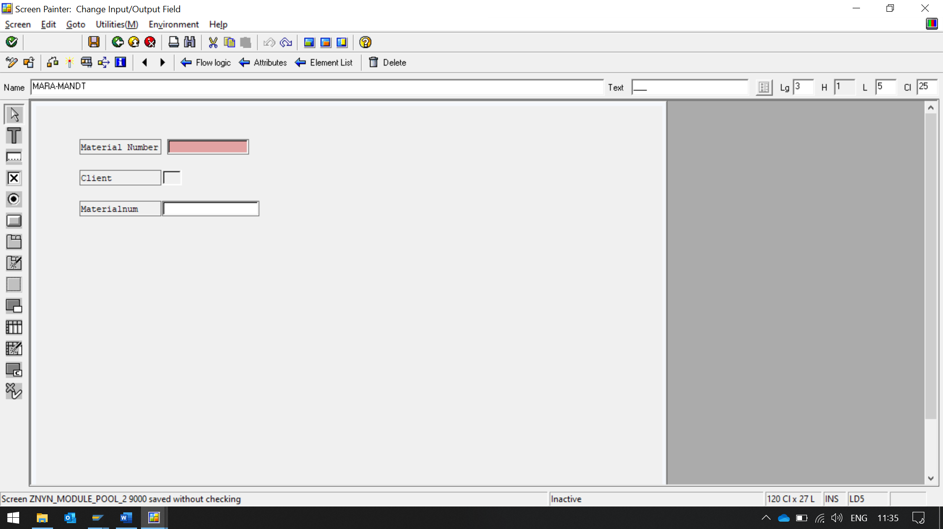

SELECT TAB STRIP

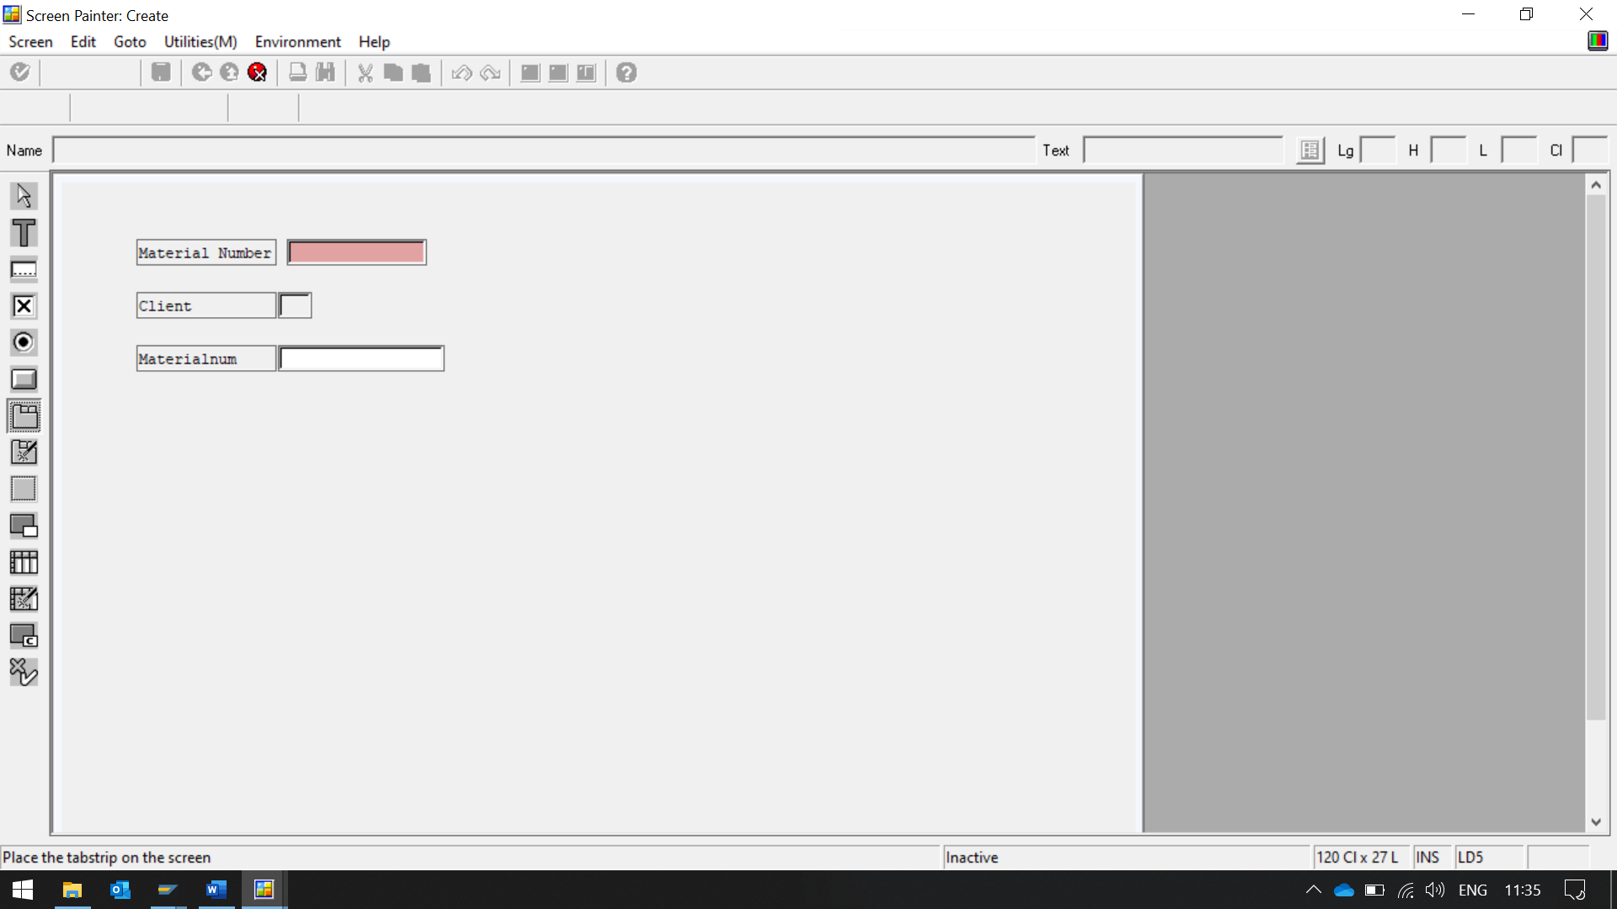

THEN PLACE IT ON THE SCREEN.

ENTER NAME AND TEXT FOR TABSTRIP.

HERE WE NAME IT AS TABSTRIP

Double click on tab strip and name it, AND CHANGE TEXT FIELD ALSO

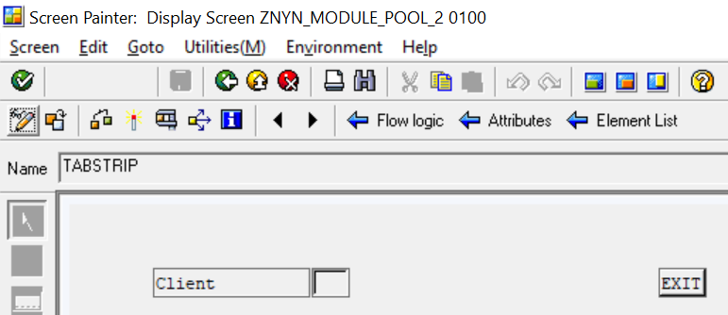

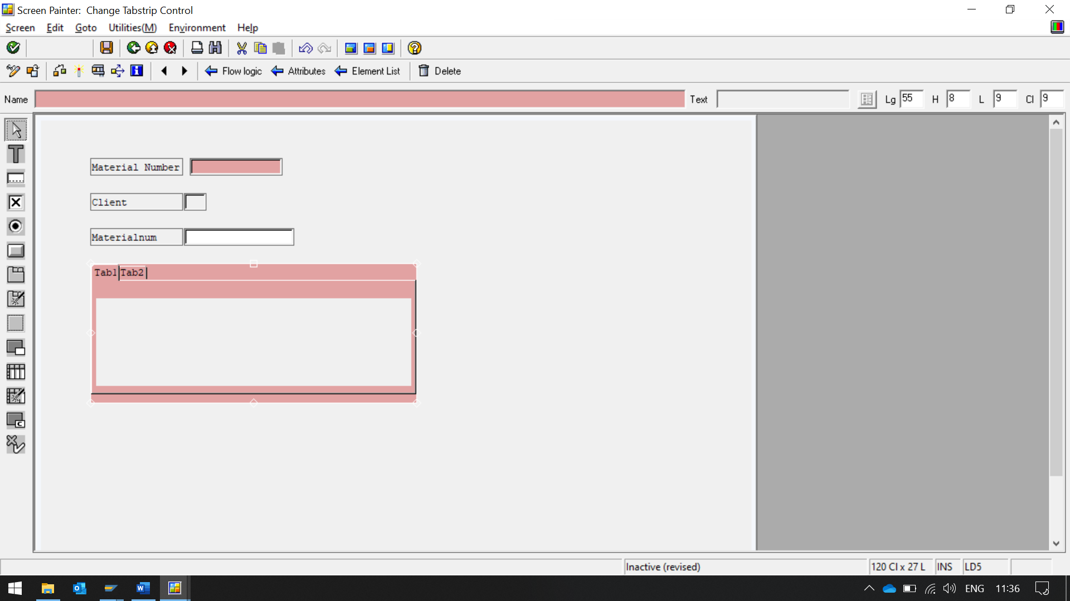

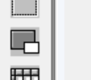 CLICK ON SUBSCREEN AREA, THEN PLACE IT IN TAB, Then click on subscreen area and drag it in the tabstrip area.

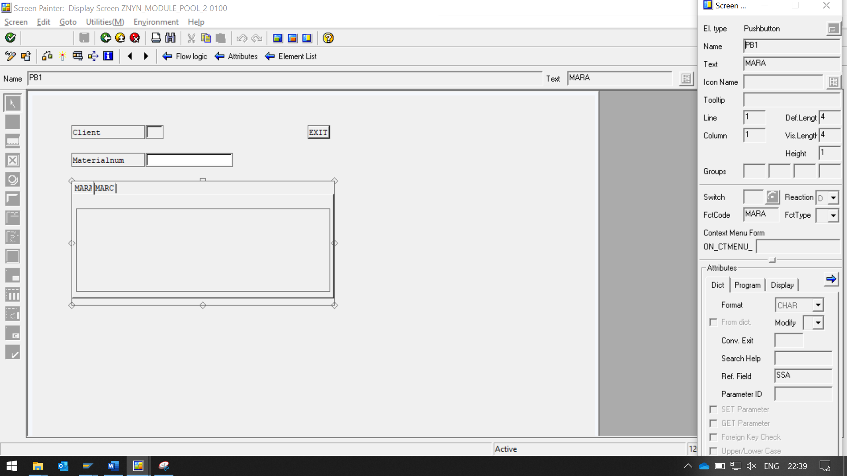

CLICK ON INDIVIDUAL TAB AND FILL THEIR PROPERTIES

NAME, TEXT, FNTCODE, REF FEILD

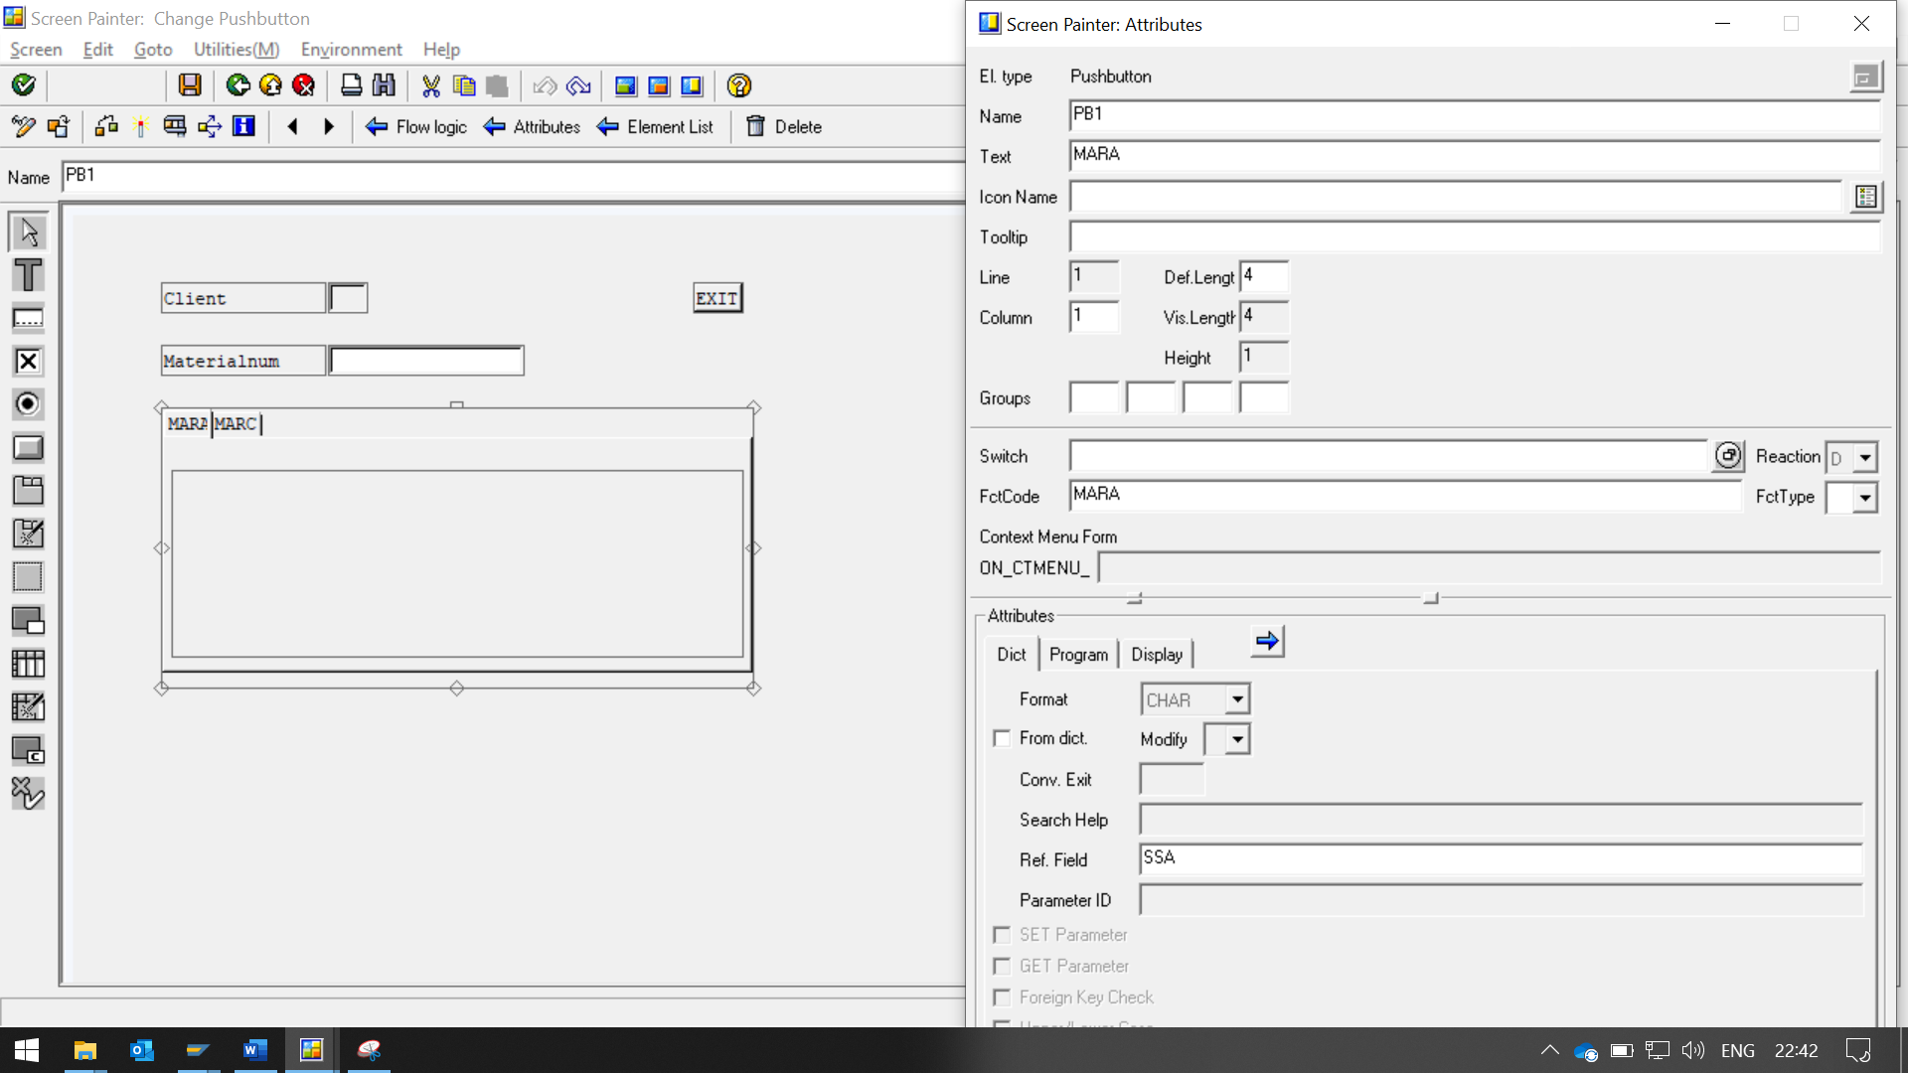

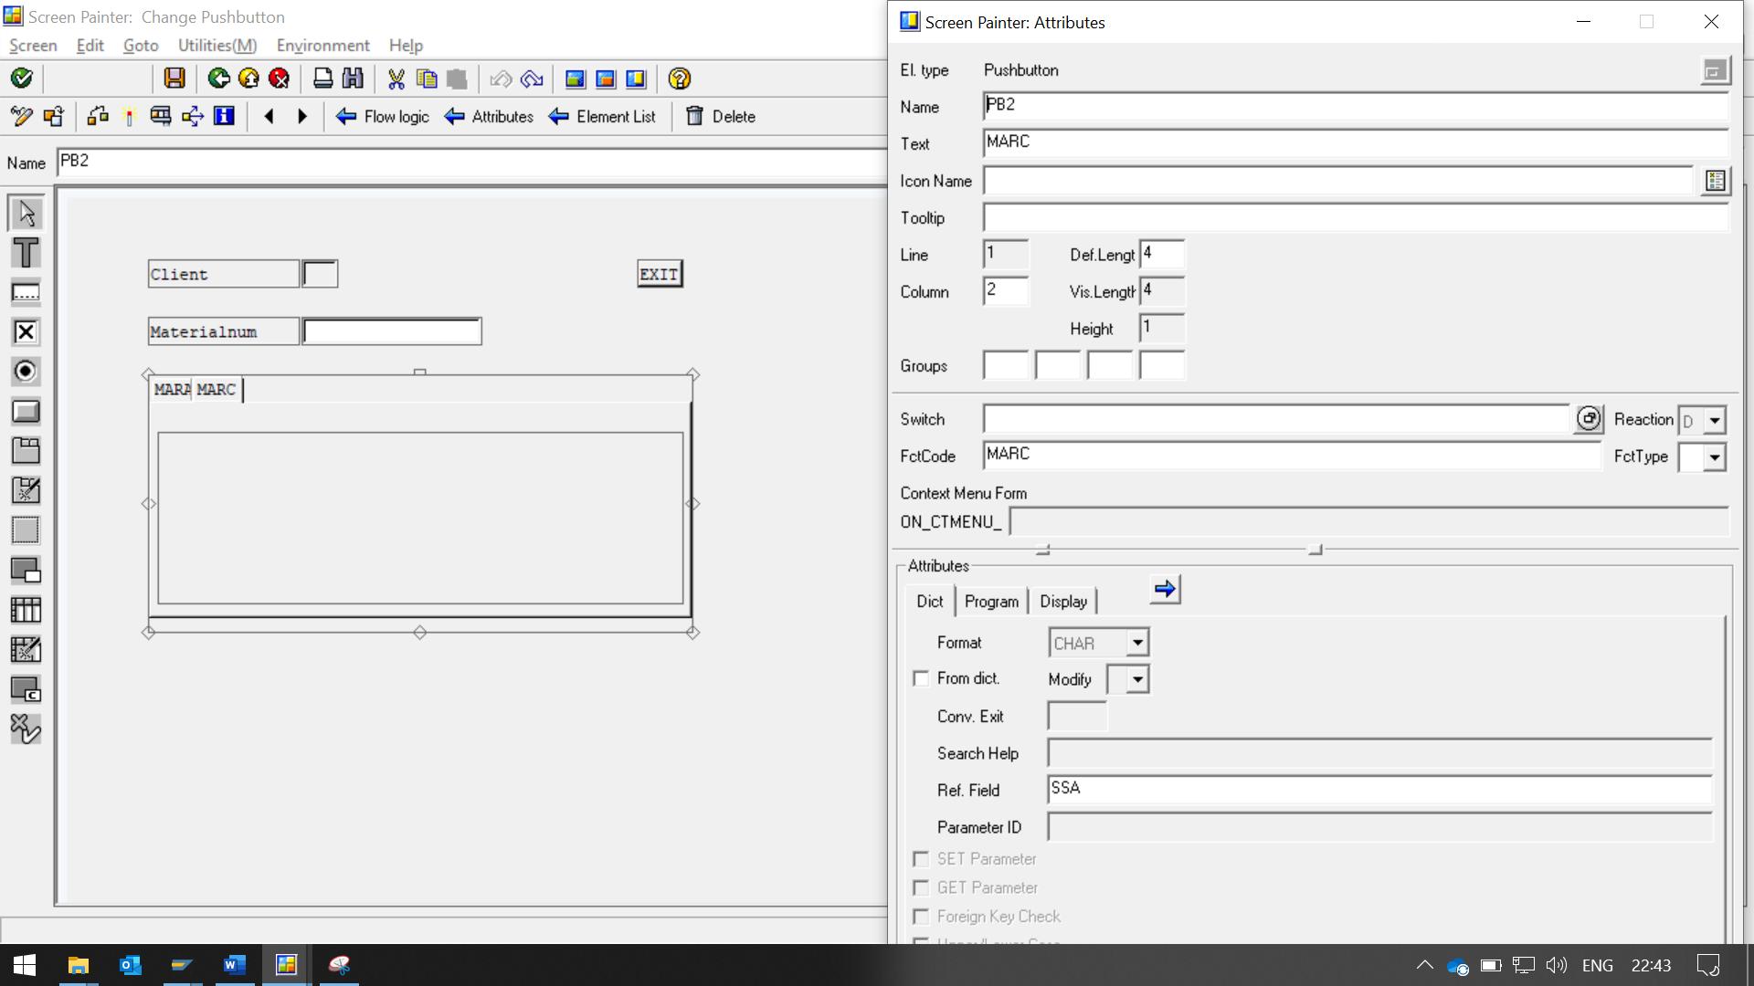

CLICK ON SUBSCREEN AREA, AND FILL ITS PROPERTIES 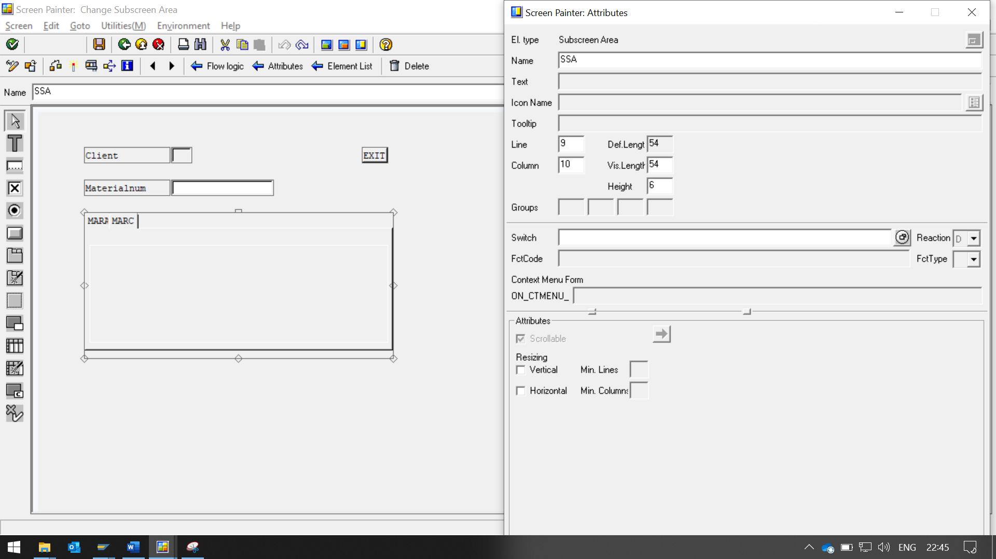

NOW TO ADD EXIT BUTTON

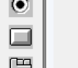

CLICK ON THE BUTTON ICON AND PLACE IT IN SCREEN.

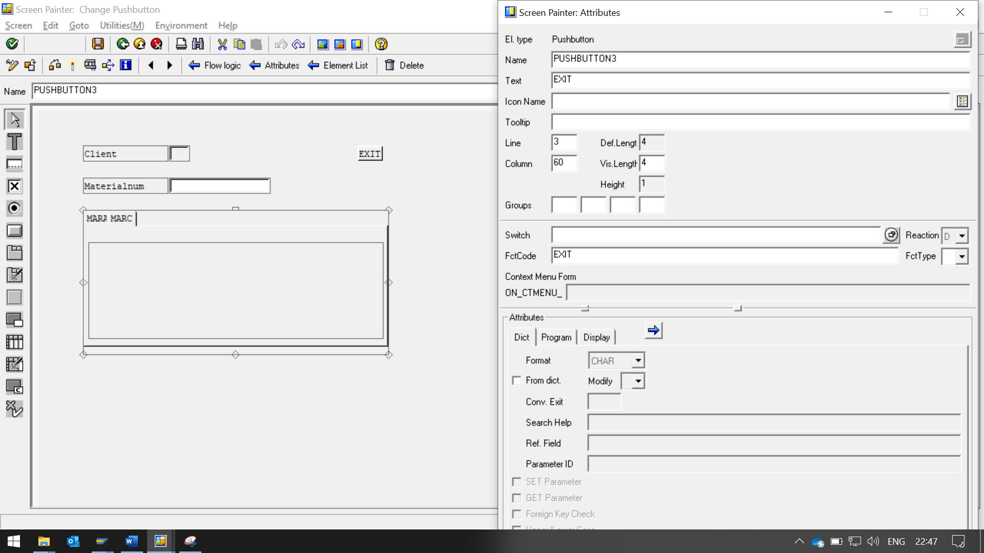

**ENTER EXIT IN FUNCTION code blank**

**CREATE SUBSCREEN 200 AND 300**

**THAN CHANGE THEIR SCREEN TYPE, ATTRIBUTE FROM NORMAL TO SUBSCREEN**

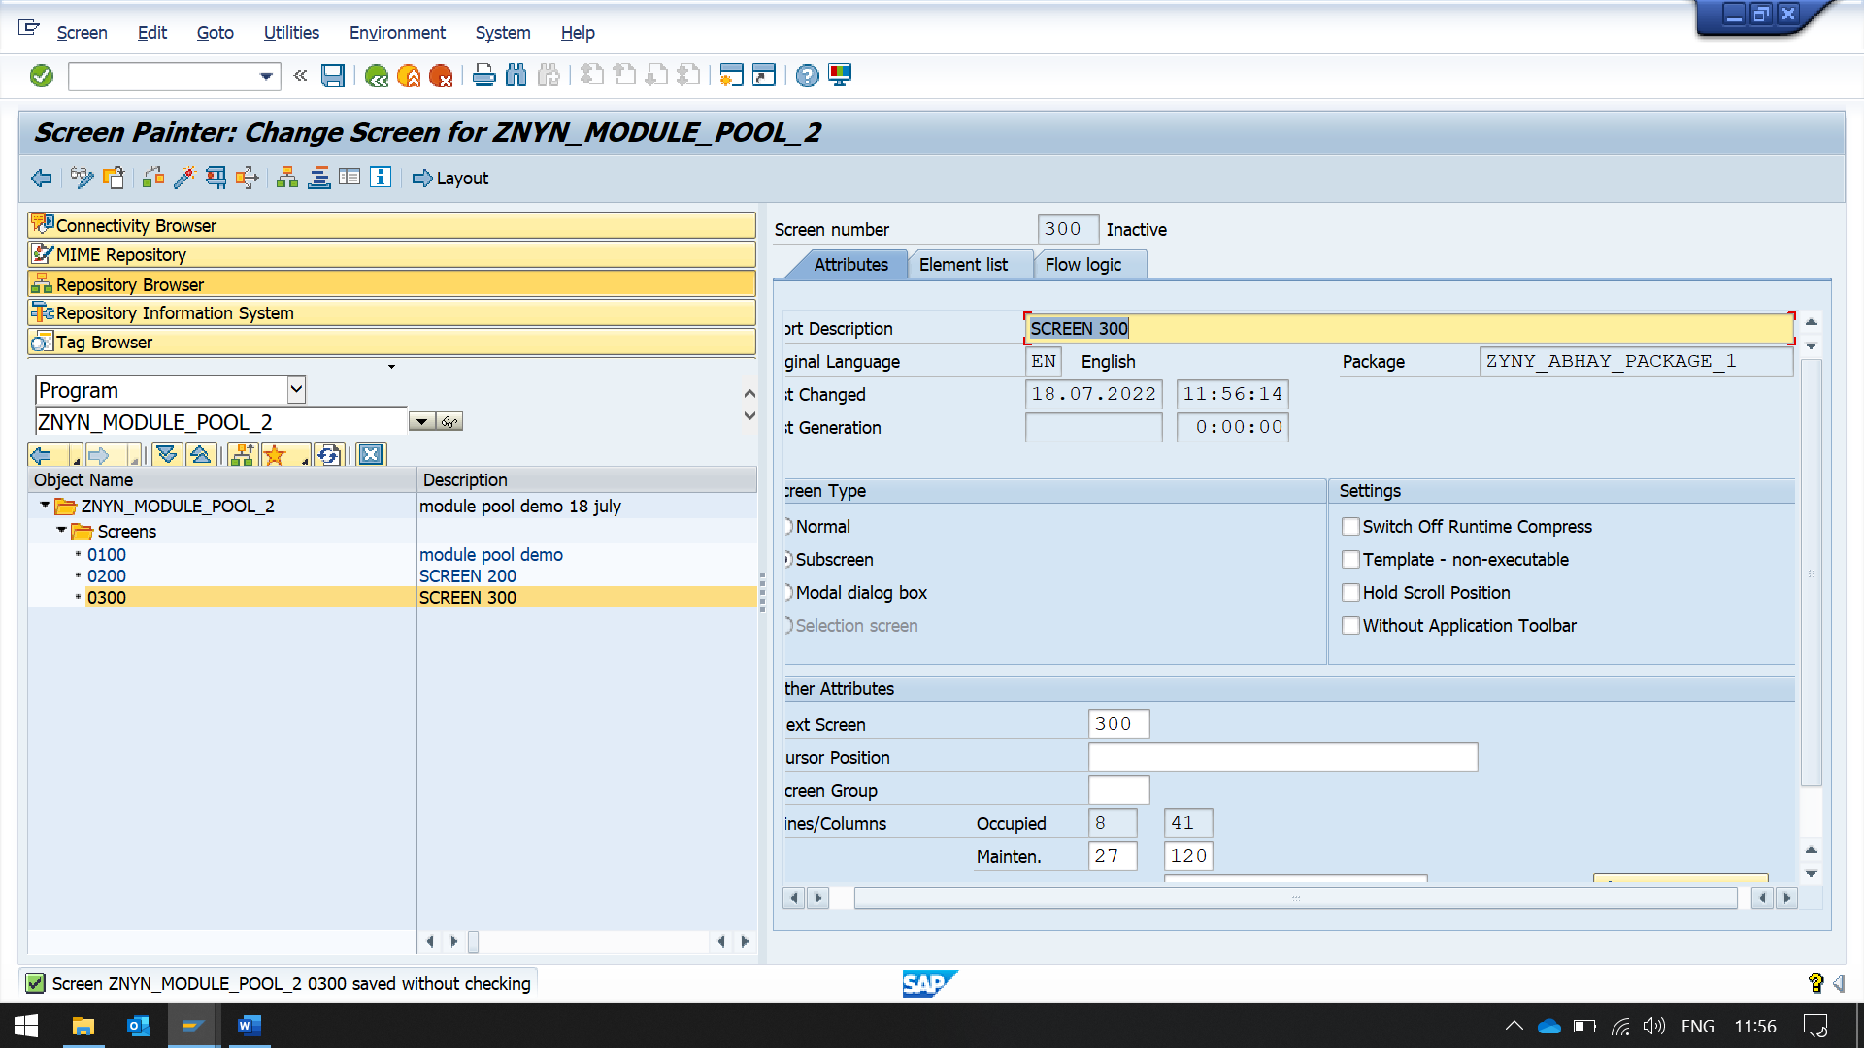

**GOTO SCREEN 100, FLOW LOGIC**

**THEN UNCOMMENT USERCOMMAND LINE**

**THEN DOUBLE CLICK ON IT TO NAVIAGTE FORWARD**

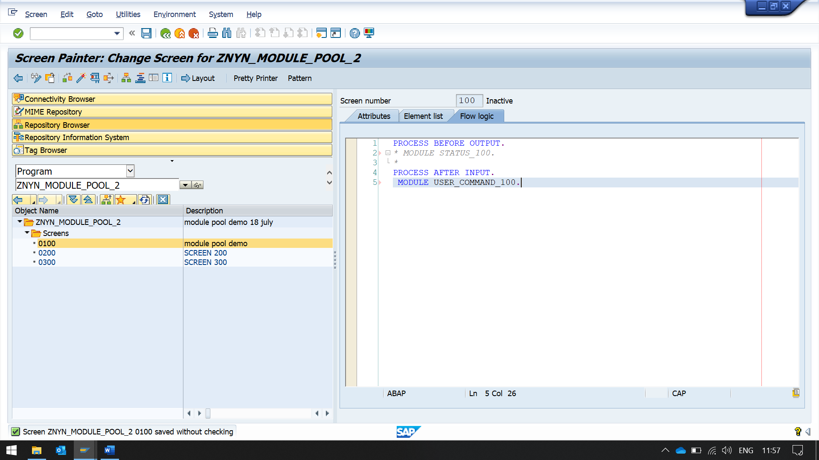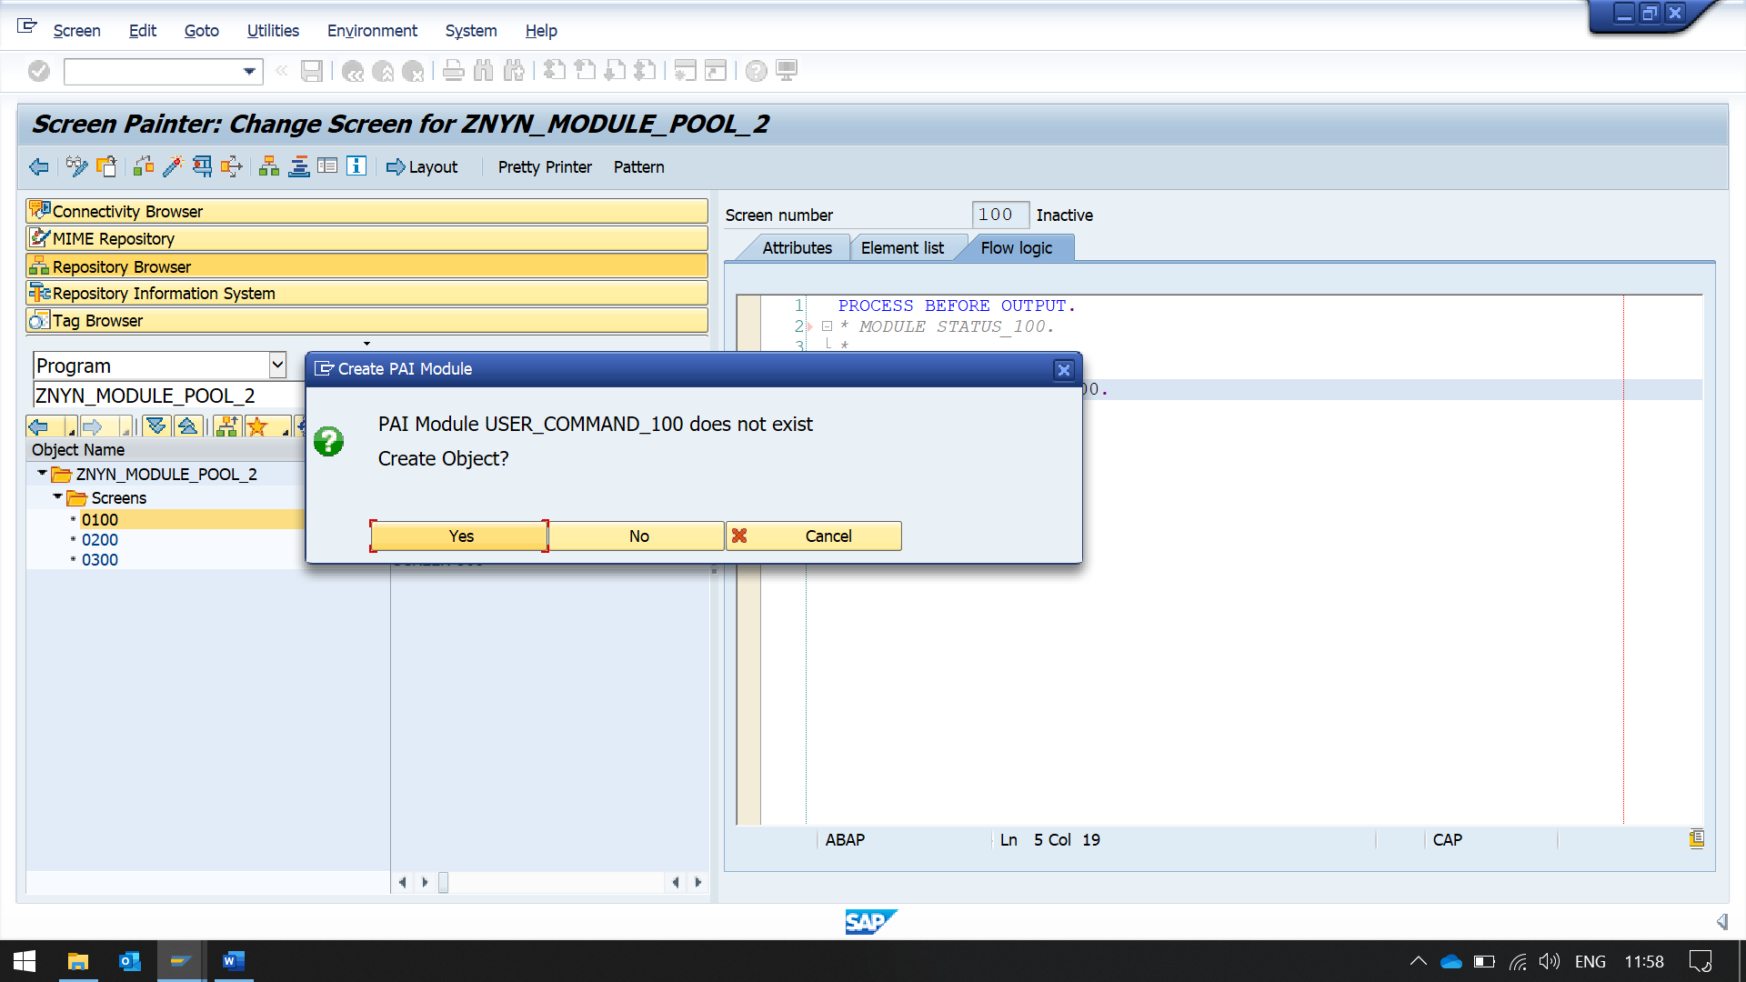

**CLICK YES TO CREATE THE LOGIC**

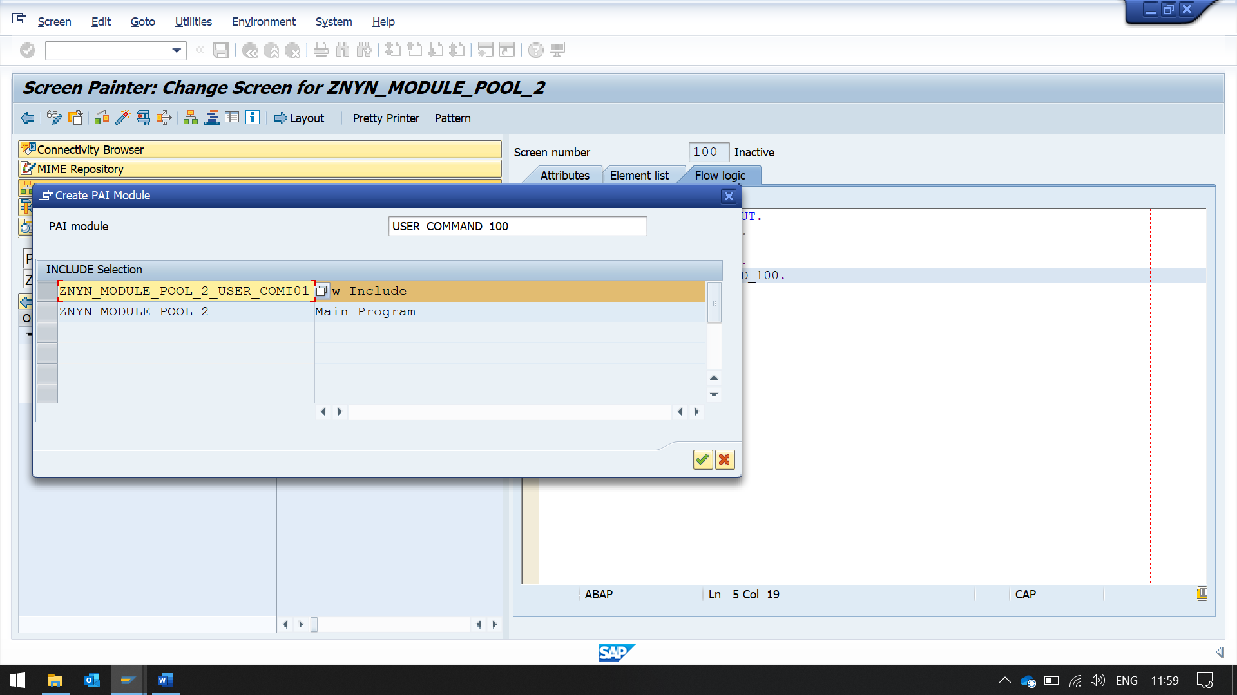

**SELECT NEW TO INCLUDE TO CREATE A INCLUDE FILE WHICH WILL CONTAIN THE CODE FROM THIS SCREEN**  
*----------------------------------------------------------------------*  
***INCLUDE ZNYN_MODULE_POOL_2_USER_COMI01.  
*----------------------------------------------------------------------*  
*&---------------------------------------------------------------------*  
*&      Module  USER_COMMAND_0100  INPUT  
*&---------------------------------------------------------------------*  
*       text  
*----------------------------------------------------------------------*  
MODULE USER_COMMAND_0100 INPUT.  
  
IF SY-UCOMM = 'MARA'.  
  TABSTRIP-ACTIVETAB = 'MARA'.  
  SELECT SINGLE * FROM MARA WHERE MATNR = MARA-MATNR.  
    SSN = 200.  
ELSEIF SY-UCOMM = 'MARC'.  
      TABSTRIP-ACTIVETAB = 'MARC'.  
      SELECT SINGLE * FROM MARC WHERE MATNR = MARA-MATNR.  
        SSN = 300.  
        ELSEIF SY-UCOMM = 'EXIT'.  
          LEAVE PROGRAM.  
          ENDIF.  
  
ENDMODULE.

**NOW ADD THIS CODE IN 100 MAIN SCREEN**

PROCESS BEFORE OUTPUT.  
* MODULE STATUS_100.  
*  
CALL SUBSCREEN SSA INCLUDING SY-CPROG SSN.  
*PROCESS AFTER INPUT.  
* MODULE USER_COMMAND_100.  
  
PROCESS AFTER INPUT.  
CALL SUBSCREEN SSA.  
MODULE USER_COMMAND_0100.

**NOW ADD TRANSACTION CODE FOR THIS MODULE POOL**

RIGHT CLICK ON THE PROGRAM FOLDER, THEN NAVIGATE TO CREATE -> TRANSACTION

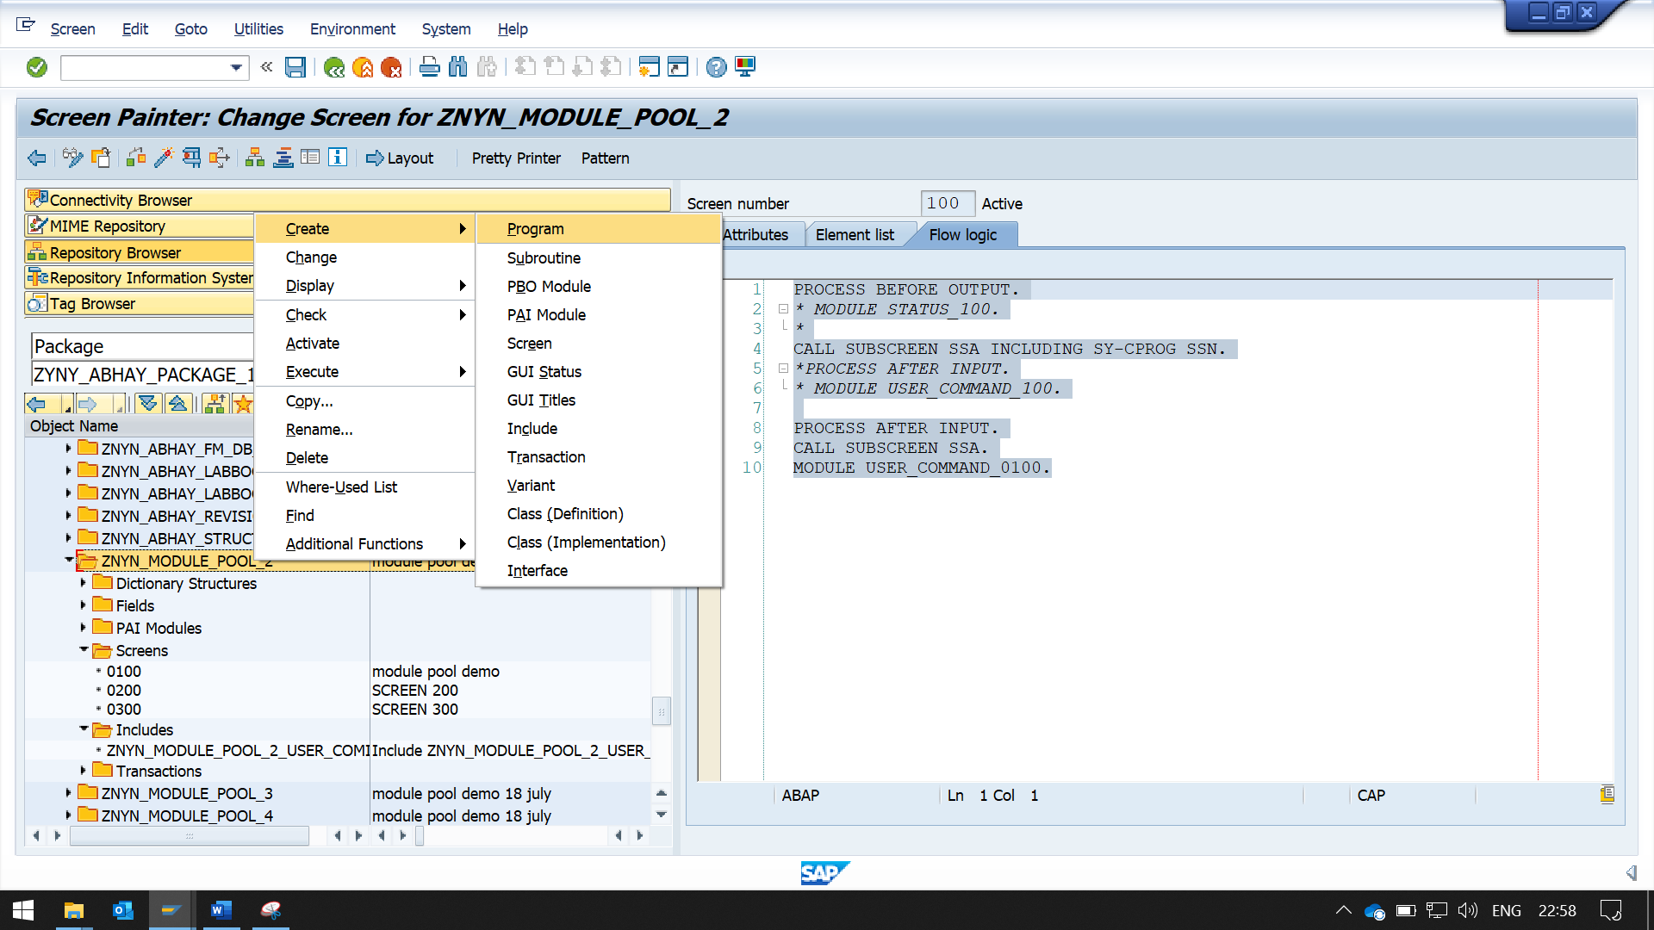

**ENTER THE FIELD**

**TRANSACTION CODE, PROGRAM AND SCREEN NUMBER, AND MARK ALL THE 3 CHECKBOX IN GUI SUPPORT**

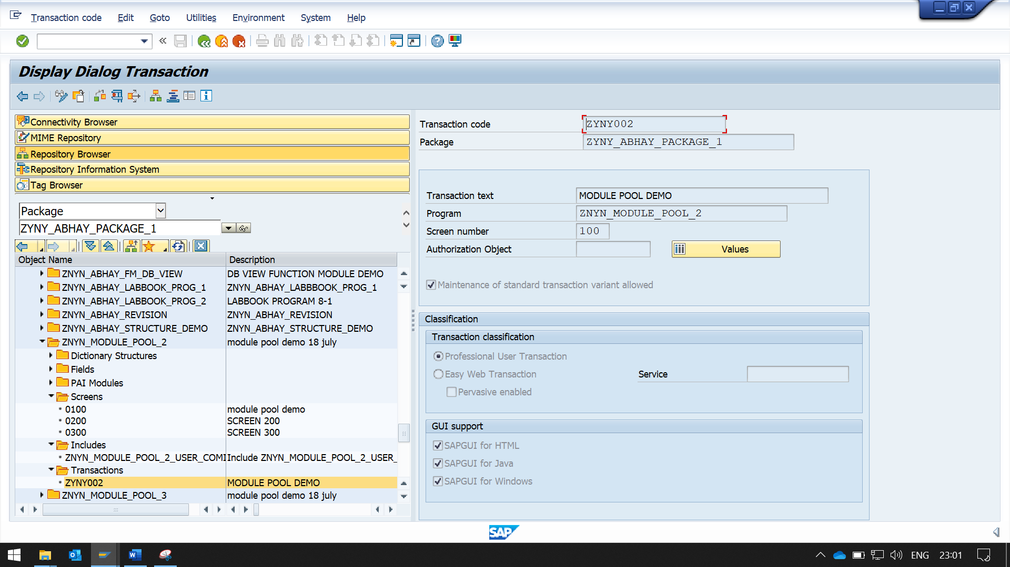

**TO ADD DEFAULT VALUES TO FIELD,**

**ADD CODE IN PROCESS BEFORE OUTPUT BLOCK**

**WE CAN’T WRITE INTIALIZATION DIRECTLY IN FLOW LOGIC.**

**WE HAVE TO ADD A MODULE, AN WRITE INITIALIZATION CODE IN IT.**

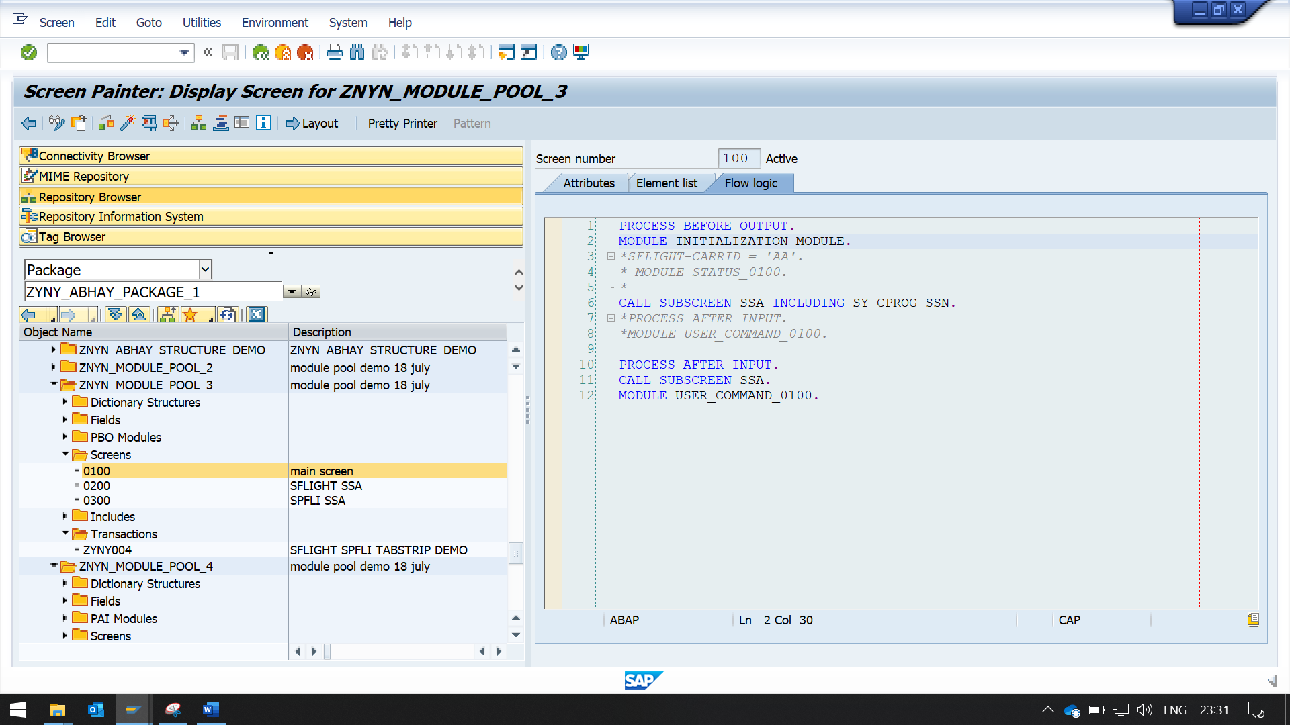

MODULE INITIALIZATION_MODULE.

**CODE**

*\*----------------------------------------------------------------------\**  
*\*\*\*INCLUDE ZNYN_MODULE_POOL_3_INITIALIO01.*  
*\*----------------------------------------------------------------------\**  
*\*&---------------------------------------------------------------------\**  
*\*&      Module  INITIALIZATION_MODULE  OUTPUT*  
*\*&---------------------------------------------------------------------\**  
*\*       text*  
*\*----------------------------------------------------------------------\**  
MODULE INITIALIZATION_MODULE OUTPUT.  
  SFLIGHT-CARRID = 'AA'.  
ENDMODULE.

**TO ADD MORE THAN 2 TAB, CLICK IN TAB STRIP AND CHANGE THE TAB TITLE ATTRIBUTE.**

